**Image Pull Policy**

In **Kubernetes**, the imagePullPolicy is a

* **Pod-level specification** that controls **when the container image is pulled** from a container registry (like DockerHub, ACR, AWS ECR, GCR, etc.)
* It tells Kubernetes **whether to pull the container image every time a Pod is started**, or only if it’s not already available on the node.

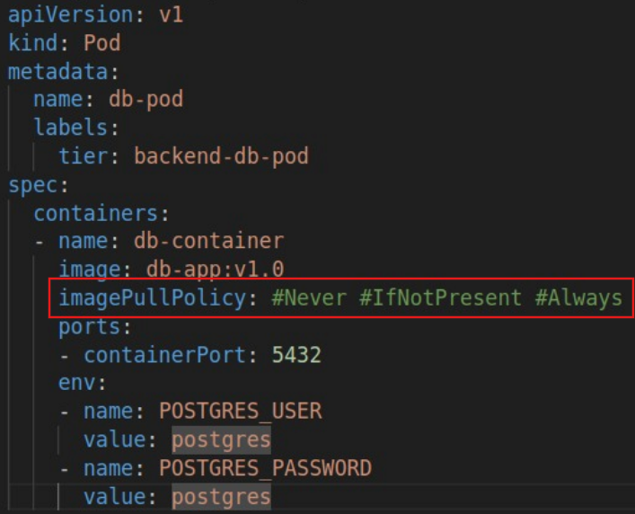

**🔹 Valid Values for imagePullPolicy**

| **Value** | **Description** |
| --- | --- |
| Always | Always pull the image from the registry, regardless of whether it's already present on the node; fail if not found on registry |
| IfNotPresent | Pull the image only if it does not already exist on the node. |
| Never | Do not pull the image. Use the local copy if it exists; fail if not found. |

**🧠 If imagePullPolicy is not explicitly set in the YAML?**

If you **don’t specify** imagePullPolicy, Kubernetes chooses a default **based on the image tag**:

| **Image Tag** | **Default imagePullPolicy** |
| --- | --- |
| :latest | Always |
| Any other tag | IfNotPresent |

**🔹 Best Practices**

* Use **IfNotPresent** with versioned images in production.
* Avoid **using :latest** in production.
* Use **Always** in development or CI/CD pipelines to fetch the latest builds.
* Use **Never** only in controlled or offline environments.